Dept. of Tamil QR code and blogger / Drive link for e-content
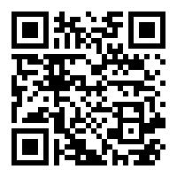

https://tamildeptgacn.blogspot.com/2020/12/b.html

